**Lab C: Parts of the Microscope re-cap and the Invisible World**

Microscopes are instrument used to observe tiny objects or organisms by enlarging it enough for us to visualize them with the human eye. There are many different types of microscopes that accomplish this is varying ways. Below are some examples of different microscopes and the images they produce.

**Stereo Microscope Optical Microscope Fluorescence Microscope**

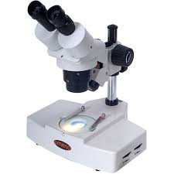 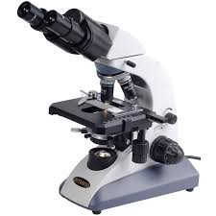 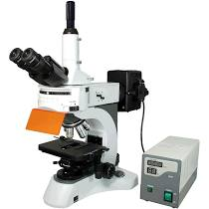

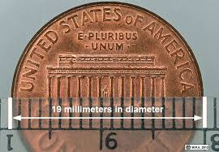 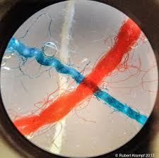 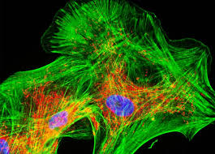

|  |  |  |
| --- | --- | --- |
| Penny under a stereoscope at 70x.  If you look closely you can see Lincoln! | Crossed threads under a microscope using a 40x objective. | Human neurons under a fluorescence microscope with a 60x objective. |

The most common kind of microscope is an optical or compound microscope, seen in the center above, which uses lenses to form images from visible light. 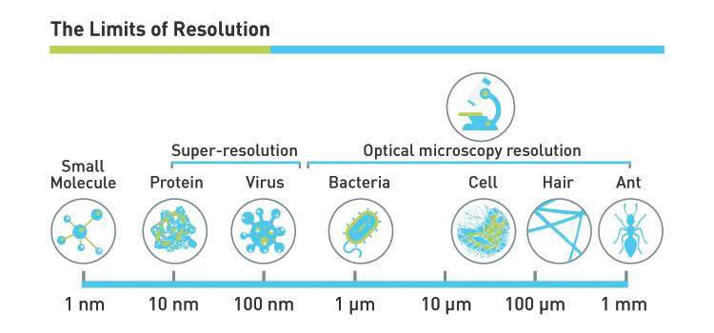

*Image adapted from West Labs

The chart above gives you and idea of the ability and limits of an optical microscope. Explore this virtual microscope before answering the questions below (you will need to fully complete the guide and learning portion as well as explore the scope and slides): <https://www.ncbionetwork.org/iet/microscope/>

Now that you have had a chance to explore the different parts and their functions try (without looking!) to label parts of the microscope:

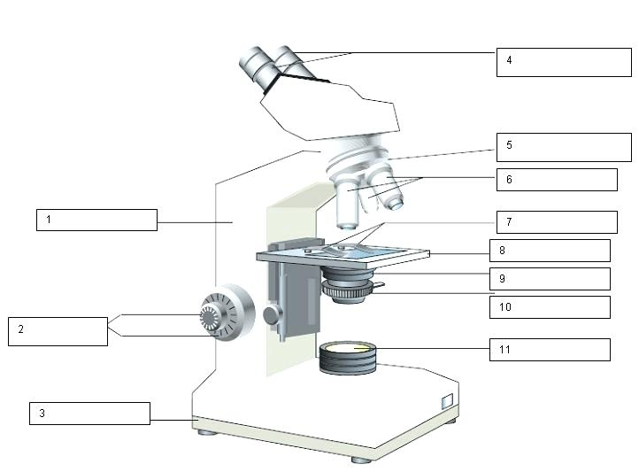

Magnification:

Your microscope has 4 objective lenses: Scanning (4x), Low (10x), High (40x), and Oil Immersion (100x).

In addition to the objective lenses, the ocular lens (eyepiece) has a magnification. The total magnification is determined by multiplying the magnification of the ocular and objective lenses. The standard ocular lens has a magnification of 10x.

In the virtual microscope you will see a box of slides. Draw a picture using a slide from each of the following categories. You may pick any slide that you like from the virtual slide box for each category, just list your choice below your drawing. Include the objective you used and the total magnification.

**Plant Cell: Bacteria: Human Cell:**

Slide name:_______ Slide name:_______ Slide name:_______

Objective used:______ Objective used:______ Objective used:______

Total magnification:_______ Total magnification:_______ Total magnification:_______

Questions:

1. Why is it important to begin focusing with the scanning objective?

2. If you’re using the 40x objective and you know your ocular is 10x, what is the total magnification?

3. If you bump your microscope and lose focus, what do you do to refocus your specimen?

4. Why must you center your image before switching to a higher objective?

Now that you are little more familiar with microscopes, its time to explore some important microscopic cells and organism.

**Prokaryotes:**

**Domain:** Bacteria

**Cyanobacteria**

***Oscillatoria***

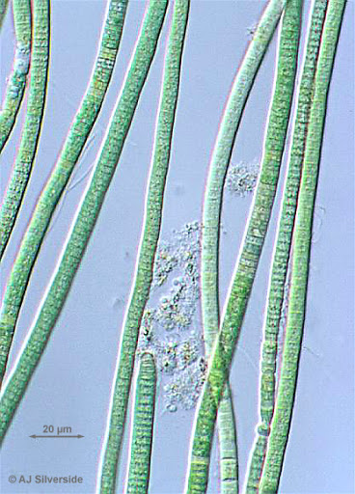

*Oscillatoria* is a **blue-green alga**, a **photosynthetic cyanobacteria**. This organism reproduces by fragmentation and forms a long filament. These filaments break into fragments called hormogonia that can grow into a longer new filament. What is interesting about this organism is that the filaments in the colony move back and forth (oscillate) against each other to reorient it in the water to direct itself to its light source.

***Anabaena***

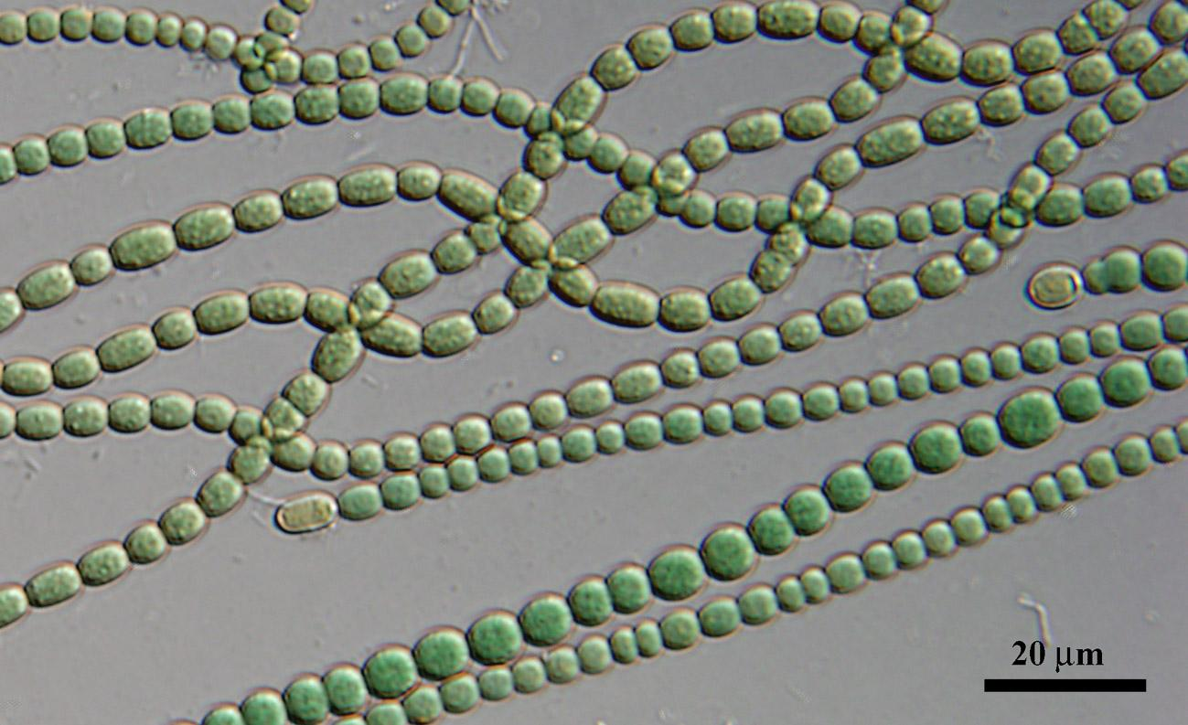

*Anabaena* is also a filamentous cyanobacteria, known for its **nitrogen-fixing** abilities. This cyanobacterium is photoautotrophic, meaning they can make their own energy using light and carbon dioxide. When nitrogen in the environment is low, vegetative cells in the filament will differentiate into a **heterocyst** which will supply neighboring cells with fixed nitrogen while the others supply the heterocyst with products from photosynthesis. The separation of these functions is important because the nitrogen fixing enzyme nitrogenase is unstable in the presence of oxygen. This organism forms symbiotic relationships with plants and can be found as plankton in shallow water and moist soil.

* Both of these organisms (*Oscillatoria* and *Anabaena*) are blue-green algae and have no chloroplast.

**Eukaryotes:**

***Spirogyra***

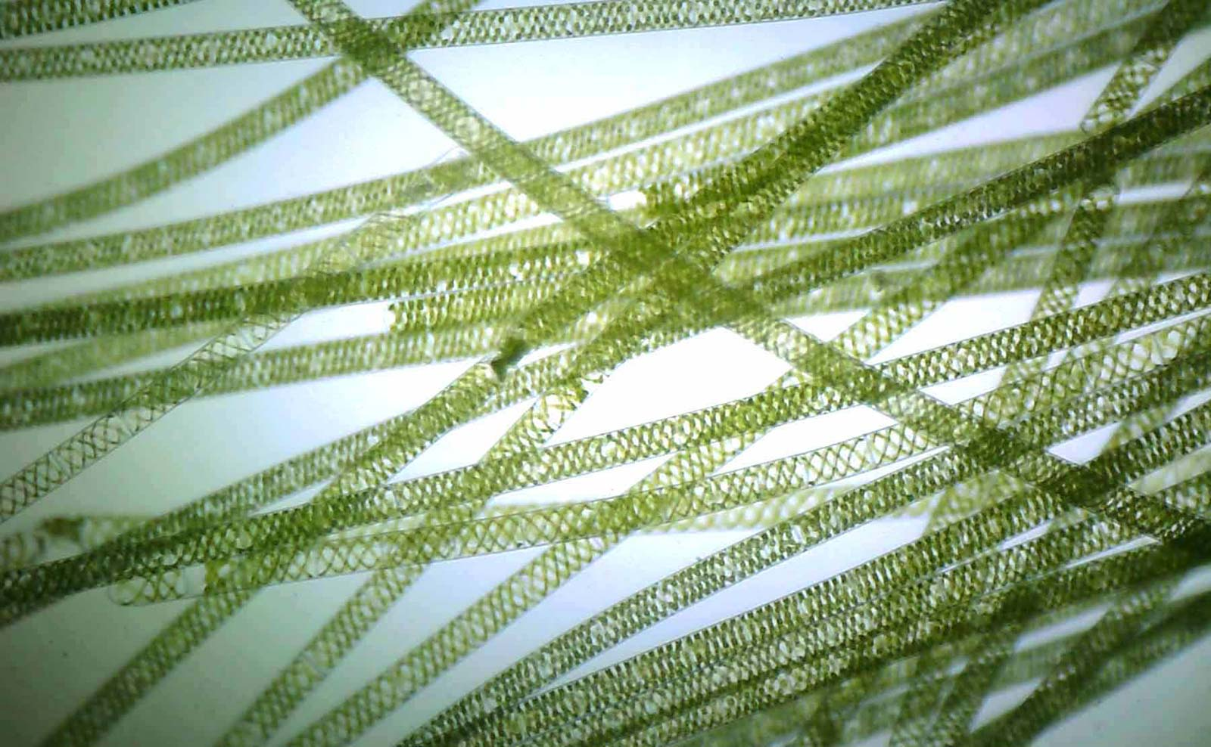

Spirogyra is a filamentous alga, as you can see above, it is named for the spiral pattern of its chloroplast. This organism is able to reproduce asexually through fragmentation, but it can also reproduce sexually through a process known as conjugation. This allows it to survive harsh changes in its environment by producing a thick-walled resting cell called a zygospore.

***Elodea***

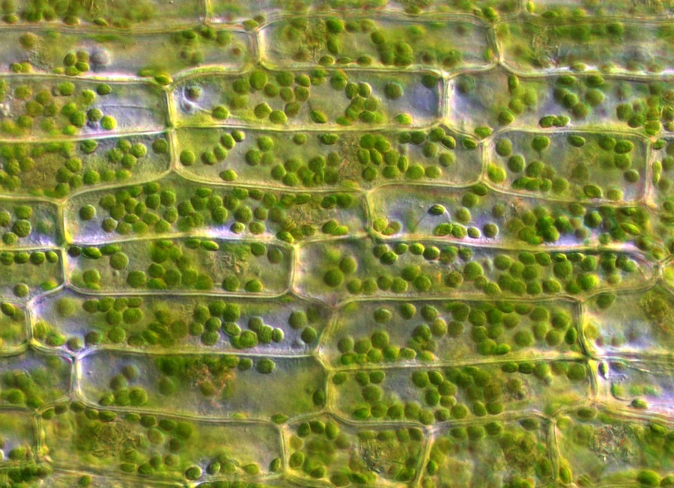

Sometimes called water weed, *Elodea* can grow in a large range of conditions. While it is important in many ecosystems, it is considered an invasive species in Alabama. Like most typical plant cells, *Elodea* has stiff box shaped cells walls filled with numerous chloroplasts with much of the volume being taken up by the central vacuole. Below you can see how the arrangement of these chloroplast change when conditions around the cells are changed.

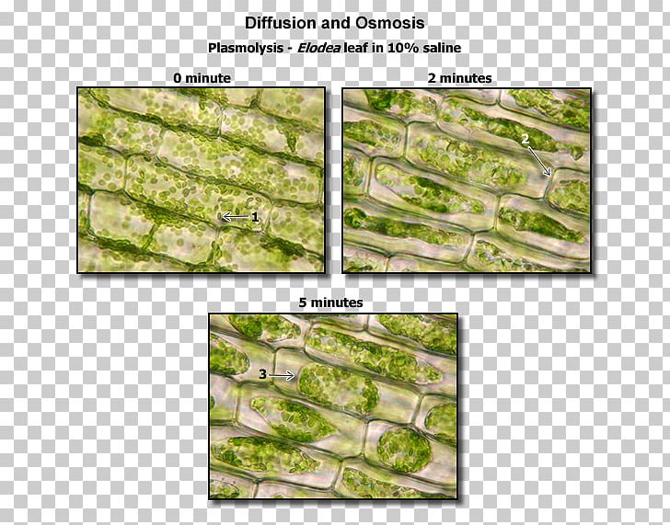

**Animal Cells**

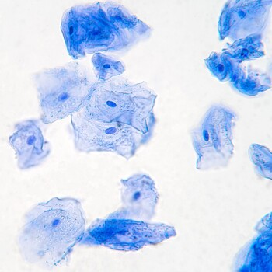

Unlike plant cells, animal cells have no cell wall, instead there is a plasma membrane. Above you can see an image of a human cheek cell stained with methyl blue, the nucleus seen as the dark spot near the center.

Animals are made up of billions of cells, all with different shapes, sizes and functions. Below we will look closer at a few different types.

**Nerve Cell:**

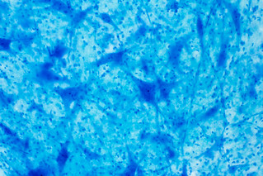

The image above shows a pig motor nerve. A motor nerve is a nerve located in the central nervous system (CNS), usually the spinal cord, that sends motor signals from the CNS to the muscles of the body.

**Muscle Tissue:**

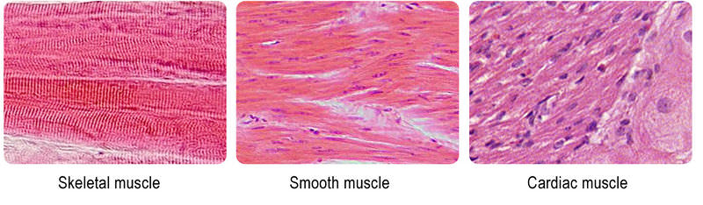

There are 3 types of muscle tissue; cardiac, smooth, and skeletal. Cardiac muscle cells are located in the walls of the heart, appear striated, and are under involuntary control. Smooth muscle fibers are located in walls of hollow visceral organs, except the heart, appear spindle-shaped, and are also under involuntary control. Skeletal muscle fibers occur in muscles which are attached to the skeleton. They are striated in appearance and are under voluntary control.

**Cuboidal Cells:**

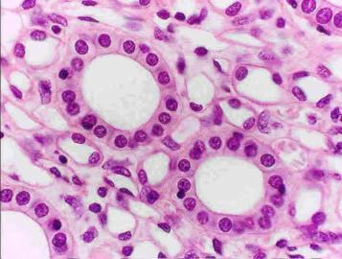

Cuboidal cells are epithelial cells that have a cube like apperance. The important functions of the simple cuboidal epithelium are secretion and absorption. This epithelial type is found in the small collecting ducts of the kidneys, pancreas, and salivary glands.

Microscopes are powerful tools that allow us to explore otherwise invisible organisms, parts of ourselves and our planet. Take a look at the video in the link below to see some of the amazing things that exist all around us.

<https://www.youtube.com/watch?v=ZyXrtODhJEA>

Adapted from <https://bio.libretexts.org/>, Lumen learning and encyclopedia of biology.